The Utah Department of Transportation (UDOT) is using hydro-demolition to remove and replace the driving surface of 14 bridges along Interstate 70 between Cove Fort and Sevier, Utah. This will be the largest project UDOT has undertaken using hydro-demolition to reconstruct bridge decks.

How it works:
The hydro-demolition machine moves over the bridge deck, using water at a force of 36,000 PSI to demolish the top 3-4 inches of the bridge deck.
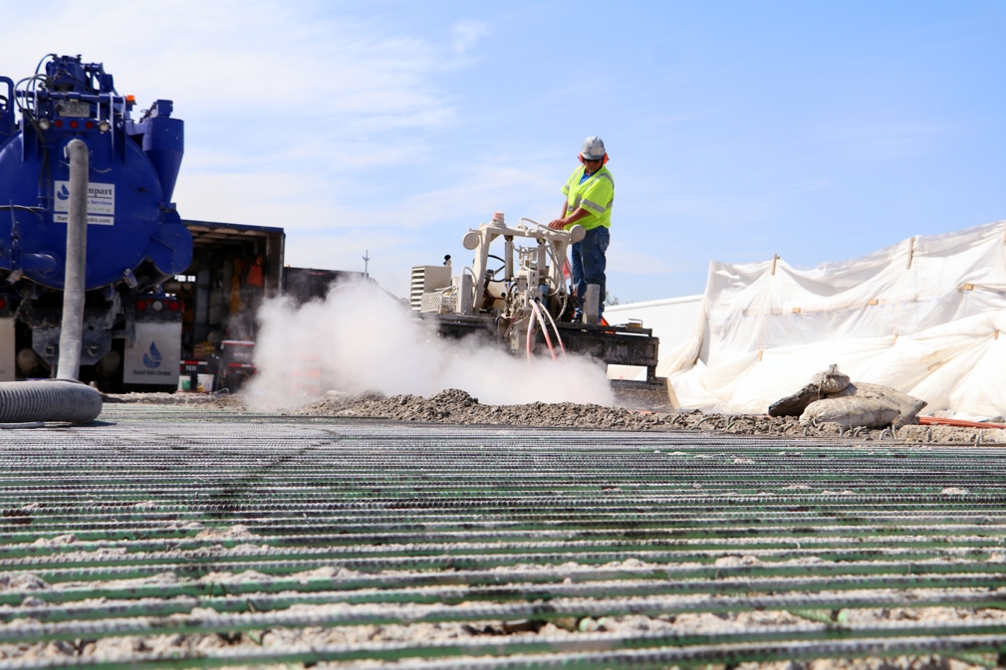
To put that into perspective, water pressure used in hydro-demolition is up to 24 times more powerful than your average home power washer. The average home power washer is between 1500-2800 PSI.

The water sprays out 15,000-17,000 gallons per 10-hour shift. This is about equal to the water in an average below-ground backyard swimming pool.

The machine operator monitors the pressure and demolition depth in real-time and uses a computer to make precise adjustments. After a few passes, another operator comes through and sucks up all the water and material with a vacuum.
- The vacuum uses a water jet – just like a dentist doing a cleaning – to dislodge debris and then suck it up.
- The water is pumped into a container, filtered, and sent to an onsite evaporation pond where the filtered and treated water will be separated from the salts.
- Concrete debris is strained from the water and then ground for use on other highway construction projects.

Benefits of hydro-demolition:
- Hydro-demolition allows precise control – leaving the reinforcing steel (rebar) intact, and only removing the top few inches of concrete.
  - Other methods like jackhammering potentially could cause structural damage and require more extensive repairs, extending the schedule and increasing costs.
- Hydro-demolition is quicker than traditional bridge demolition methods.
- Hydro-demolition reduces the dust and vibration experienced by nearby residents.

Other past projects to have utilized this method include multiple projects on I-215 Salt Lake County, I-15 in Box Elder County and U.S. 40 in Summit County.

